Factors Impacting the Use of Telehealth for Medicare and Medicaid Members in 2020-2024

**Jessica Coomber**

Data Analytics 401 - Senior Seminar

Dr. Alexandre Scarcioffolo

Denison University

2025

**Abstract**

This research aims to understand the factors impacting the use of telehealth visits for Medicare and Medicaid members in the US during 2020-2024. The *Medicare Telehealth Trends* dataset is merged with publicly available data from the US Census Bureau, the *Transit Report Card* from Transportation for America, and Federal Reserve Economic Data (FRED) in order to include variables that suggest economic status of an individual. Fixed effect analysis is used to assess the relationship between the variables and the number of telehealth visits per capita, while controlling for state and year. The results suggest that the number of vehicles owned and transit spending per capita are positively associated with telehealth visits. The number of physicians is also associated with more telehealth, but more hospitals is associated with fewer telehealth. Variance Inflation Factors **(**VIF) found multicollinearity among internet access, GDP, and unemployment rate, making it difficult to interpret their individual impacts. This research can be used to understand potential socioeconomic barriers to telehealth access to aid opportunities for targeted interventions to improve equitable access to care.

**Introduction**

The use of telehealth has increased since 2020 and it is often assumed that it’s bridging a gap in need for healthcare. However, it could be falling short of its potential to improve access to care for everyone in the population. This research aims to determine factors that are impacting the use of telehealth for Medicare and Medicaid members. I focus on factors that suggest economic status of individuals, such as number of vehicles owned and types of internet access, to see how they are impacting the utilization of telehealth visits. I expect that disadvantaged populations with a perceived lower economic status will also show a lower utilization of telehealth services because of the financial barriers to its access. A potential limitation of the results is that there is not one variable to represent the economic status of the individuals so inferences will have to be made based on other variables.

**Literature Review**

Existing research on the use of telehealth highlights its potential to expand access to medical care. In order to understand its impact, it is important to clarify what types of services telehealth refers to. The term telehealth is mistakenly thought of as only including video calls, but it also includes phone consultations, secure messaging, remote monitoring of health through wearable devices (Wosik, 2020). The adoption of telehealth increased during the COVID-19 pandemic and it has become more mainstream in recent years (Wosik, 2020 ; Gajarawala and Pelkowski, 2021). Even with the increased adoption of telehealth in the US, concerns remain around whether there is actually an improvement for lower income populations who might not have access to the internet or technology and they might not have the same comfort using technology (Douthit, 2015). My research will support Douthit’s perspective questioning whether it is truly bridging gaps in healthcare access or if it is increasing existing disparities. This literature review will explore themes such as access to healthcare, access to telehealth and its utilization trends, and healthcare costs. Understanding these factors is important in understanding how to reach telehealth's potential to improve the equality of healthcare access and overall population health.

Singh et al., (2018) identifies that some of the ongoing barriers of healthcare access come from social determinants of health, which include community factors such as socioeconomic status and geographic location. The use of telehealth services to provide healthcare access remotely has evolved significantly in recent years, particularly during the COVID-19 pandemic when there was a need for a fast adoption and integration of telehealth into healthcare systems (Wosik, 2020 ; Gajarawala and Pelkowski, 2021).

Tuckson (2017) highlights telehealth's progress in expanding care access, addressing provider shortages, and increasing convenience. On the other hand, Douthit et al. (2015) suggests that rural populations, low-income communities, and elderly individuals often face difficulties in utilizing telehealth services because of low technological comfort and unreliable internet access. A key factor contributing to these barriers in access to telehealth is that about 1/4 of American households in rural areas are lacking internet access, making virtual healthcare inaccessible to many who need it the most (Lythreatis et al., 2022 ; Douthit et al., 2015). Although it may seem like telehealth can be used to connect rural hospitals with specialists, increase access care for underserved communities, and make the healthcare system more efficient, it is important to assess whether this is actually the case given the barriers socioeconomically disadvantaged populations may still face to access telehealth (Wosik, 2020).

The increased use of telehealth is seen in an analysis of private insurance data, which shows that telehealth visits increased from 0.3% of total healthcare contacts in 2019 to 23.6% in 2020 (Weiner, 2021). These privately insured individuals may be wealthier and represent a more privileged portion of the US population who was more easily adaptive to new technologies. It is also possible that this new utilization may increase overall health care spending even though there are lower costs per telehealth visit for patients because it may reach a previously unmet demand by individuals who would not have seeked any care if it were only offered in person (Ashwood et al., 2017).

To understand the impact on cost, Ashwood explores the financial implications of telehealth, particularly its impact on healthcare spending and the diverse approaches to insurance reimbursement. The increased utilization of telehealth does not necessarily correlate with reduced healthcare spending (Ashwood et al., 2017). Telehealth visits often serve as an additional point of care rather than a direct replacement for in-person visits, potentially leading to higher cumulative healthcare costs.

For example, a study by Weiner (2021) found that people who used telehealth had higher overall medical costs. However this correlation does not necessarily mean that telehealth is more expensive but could mean that those people could have already been dealing with more health problems and are therefore using telehealth more frequently. Individuals with high medical needs may not prefer in person appointments because they require time off from work and have additional travel costs (Ashwood et al., 2017). These cost-related challenges could be reduced for certain types of appointments like routine check ups and follow ups that would only cost $40-50 as a telehealth visit (Ashwood et al., 2017).

Another financial challenge in regards to telehealth is that the reimbursement policies vary significantly between insurers, with Medicare and Medicaid offering limited coverage compared to private insurers (Gajarawala and Pelkowski, 2021). The lack of standardized billing practices makes it complicated to assess the cost-effectiveness of telehealth. Medicaid programs in certain states have embraced telehealth expansion, others are still more restrictive, creating disparities in access to care based on geographic location (Tuckson et al., 2017).

**Data**

The dataset used in this research is the *Medicare Telehealth Trends* from the U.S. Department of Health & Human Services which is publicly available through Data.gov, a platform that provides open government data permitting use for research. The variable names were renamed from the names in the original dataset for easier interpretation. Variable definitions were found in the *Medicare Telehealth Trends Data Dictionary.* This dataset includes the demographic information about Medicare and/or Medicaid members and whether they reported using telehealth services during and after the pandemic. The observations in this dataset are anonymous and I will not be handling specific personal health information.

The *Medicare Telehealth Trends* dataset includes their demographic variables (i.e. race, sex, state), the number of telehealth visits and the number of visits that were eligible to have been telehealth. The number of telehealth visits will be used as the dependent variable of interest as I am trying to understand telehealth utilization. A potential limitation of this study that could affect the interpretation of the results is that the data includes years 2020-2024 but does not include information about telehealth usage before 2020. Without data from before 2020, it is difficult to determine whether the results differ from earlier years due to the COVID-19 pandemic. Similarly, without the inclusion of data from a larger period, analysis was not done based on year.

The *Medicare Telehealth Trends* data is merged with publicly available annual data from the US Census Bureau on state specific factors that could be impacting access to telehealth. The US Census Bureau data includes population sizes as well as various variables relating to vehicle access and internet access. These variables are chosen because I hypothesize that the owning vehicles and having internet access vary based on the individual's economic level and therefore impact the ability to access medical care and telehealth services. The vehicle and internet variables are converted to be representing per capita for easier interpretability.

The *Medicare Telehealth Trends* data is also merged with the *Transit Report Card* from Transportation for America to capture individuals who depend on public transportation in each state. The Transit Spending Per Capita variable is chosen to represent public transportation use of individuals who are likely in urban areas. Transit Spending for each state is adjusted to per capita to fairly compare states of varying sizes.

Additional variables are chosen from Federal Reserve Economic Data (FRED) including annual GDP in billions and unemployment rate as a percentage which are merged to the *Medicare Telehealth Trends* dataset based on year. GDP is converted into a new variable GDP in trillions for easier interpretability in the models. Similarly, unemployment rate has been converted from a percentage to a proportion for easier interpretability. GDP and Unemployment are used to represent the economic status of the US in order to see whether there is a relationship in the economy to telehealth usage.

**Methods**

For initial exploration, I used bar plots to visualize TelehealthVisits (number of unique telehealth visits) across demographics categories (rural/urban, race, and year). These variables are important in understanding the dataset because demographics of individuals influence their ability to access telehealth services (Ching-Ching, 2018). Next, I use a fixed effect analysis to assess the strength of the impact that various variables have on the number of telehealth visits and how that relationship changes once controlling for state and year. Fixed effect models controls for time invariant variables and in this case will control for differences between states and years. Fixed effect will be a beneficial method because it will help isolate variables of influence to see how they are impacting the utilization of telehealth services. 7 variables have been chosen for the multivariable fixed effect model in relation to telehealth visits. The variables include: the number of vehicles owned, transit spending per capita, having internet access, number of hospitals, number of physicians, GDP, and unemployment rate. To evaluate the fit of the model, the R^2 will represent how well the model explains variation within each fixed-effect group (no fixed effect, state fixed effect, and both state and year fixed effect). A higher R^2 will suggest that the independent variables are good predictors of Telehealth visits.

**Model Validation**

Standard Errors will be used to assess the validity of the model because they represent the uncertainty and precision (Altman, 2005). Ordinary standard errors are often unrealistic when working with real data because they assume that the errors are homoscedastic (constant variance) and are uncorrelated across observations. For this reason, I will be using the function feols (fixed effects ordinary least squares) in R which defaults to “cluster” when using fixed effects. Cluster assumes that the error terms within the same cluster are correlated. This is needed for the fixed effect model because the data within the same cluster is autocorrelated (correlated with each other). Feols drops variables that are perfectly collinear but if a variable has very high VIF, it might still be problematic and could lead to unstable estimates.

Variance Inflation Factor (VIF) analysis is used to test for multicollinearity, which is when independent variables are highly correlated with each other. When independent variables are highly correlated, the fixed effect model will not be able to determine which variable is leading to the effect and in this case it will capture overlapping aspects of economic status. Correlated variables in a fixed effect model could lead to unreliable coefficient estimates and the interpretation of the impact of each variable could be incorrect.

**Results**

**Figure 1: Telehealth Visits by Rural vs. Urban**

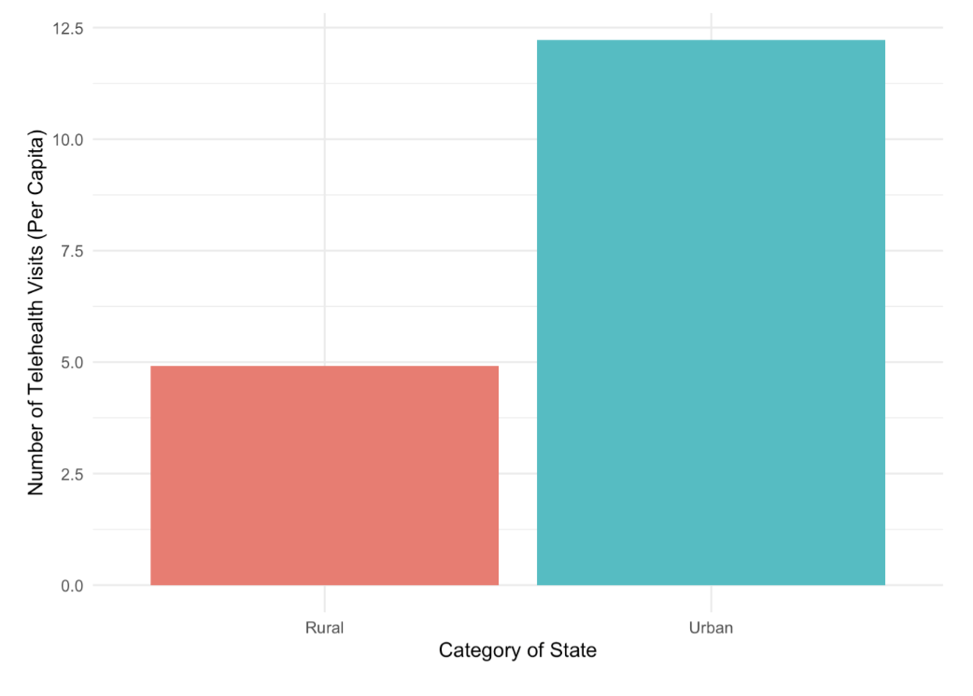

**Note:** Rural/Urban status is defined using the beneficiary’s mailing ZIP code and the Rural Urban Commuting Area Crosswalk (RUCA). The RUCA crosswalk relies on commuting data from the US Census.

***Figure 1*** shows almost 12.5 telehealth visits (per capita) for urban individuals and only about 5 telehealth visits for those who are rural, which could be because of differing socioeconomic status and access to the internet. Singh et al., (2018) identified that community factors, such as socioeconomic status and geographic location, are associated with ongoing barriers of healthcare access. Rural populations have a higher lack of access which is an issue with over 51 million Americans who live in rural USA (Douthit, 2015).

Another key factor contributing to these barriers in access to telehealth is the digital divide, with about 1/4 of American households in rural areas lacking internet access, making virtual healthcare inaccessible to many who need it the most (Lythreatis et al., 2022 ; Douthit et al., 2015). Even though telehealth is thought to be expanding care access, Douthit et al. (2015) suggests that certain populations like the rural, low-income communities, and elderly, have more difficulty using telehealth services because of low technological comfort and unreliable internet access. ***Figure 1*** reinforces Douthit’s concern that telehealth is not reaching its potential and rural populations are lacking.

**Figure 2: Telehealth Visits by Race**

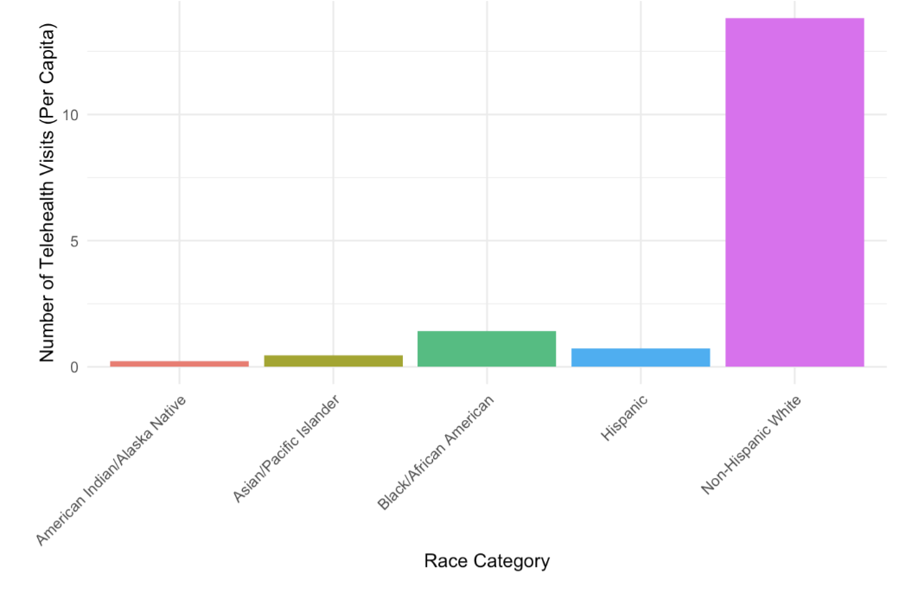

***Figure 2*** shows that telehealth visits are much more common among Non-Hispanic White population. This could be because of the advantages and resources available to this demographic, suggesting a need for targeted approaches to increase utilization among other race groups. Recognizing that non-white populations have much lower number of telehealth visits can help target the allocation of resources and education programs relating to the implementation of telehealth to improve its access.

**Figure 3: Telehealth Visits by Year**

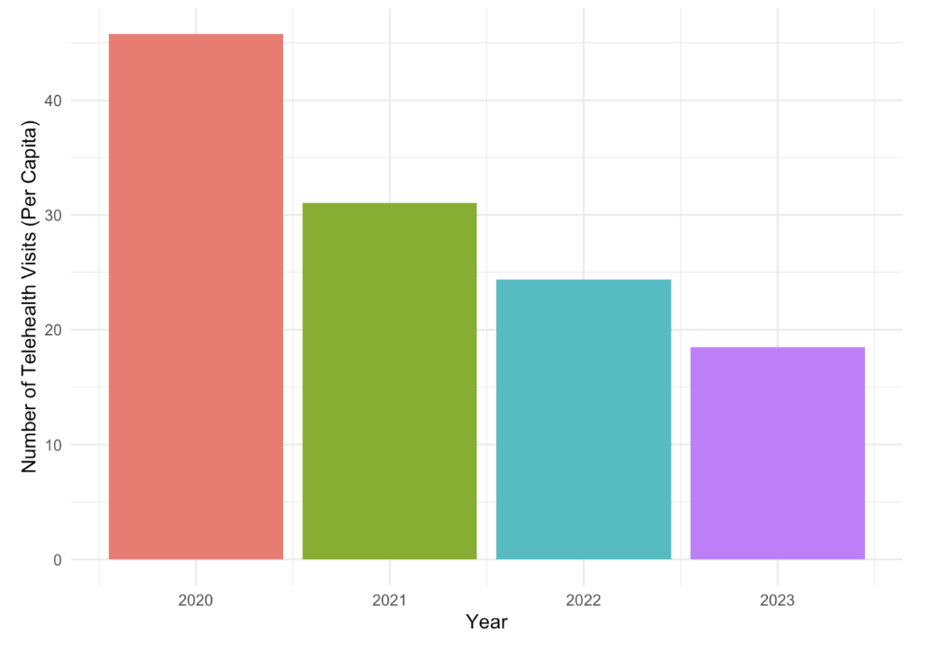

**Figure 4: Eligible Services (With Potential for Telehealth Use) by Year**

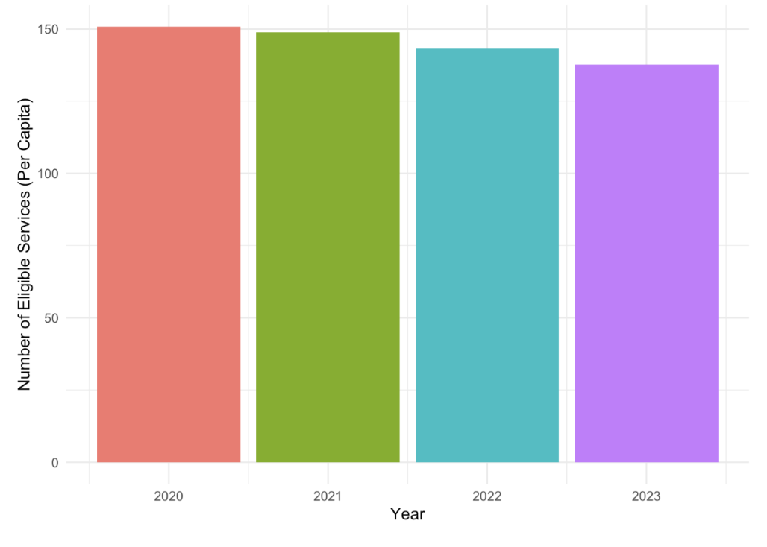

***Figure 3*** shows the number of telehealth visits while ***Figure 4*** shows the number of eligible services that could have been used by telehealth by year. **Figure 3** shows the number of telehealth services was the highest in 2020, likely because the pandemic forced almost all in person visits to become virtual. However, ***Figure 4*** suggests that since 2020 there has only been a small decline in the number of services that are eligible for telehealth use. There are about 150 eligible services (per capita) for each year and only fewer than 50 telehealth visits. Therefore, this research will provide insight into ways that the use of telehealth services can increase and which populations are currently lacking versus accessing those eligible services.

**Table 1: State and Year Fixed Effects on Various Factors impacting the Number of Telehealth Visits (Per Capita)**

|  |  |  |  |
| --- | --- | --- | --- |
| **Variable** | **No Fixed Effect** | **State Fixed Effect** | **State and Year Fixed Effect** |
| **Vehicles Owned** | **0.010+** | **0.116\*\*\*** | **0.100\*\*\*** |
|  | (0.006) | (0.021) | (0.022) |
| **Transit Spending Per Capita** | **0.000\*\*\*** | **0.006\*\*\*** | **0.005\*\*\*** |
|  | (0.000) | (0.001) | (0.001) |
| **With Internet** | **-0.013+** | **-0.091\*\*\*** | **-0.064\*\*** |
|  | (0.007) | (0.015) | (0.020) |
| **Hospitals Count** | **-35.235\*\*\*** | **-1655.187\*\*\*** | **-1667.191\*\*\*** |
|  | (5.027) | (323.603) | (323.618) |
| **Number of Physicians** | **2.114\*\*\*** | **88.606\*\*\*** | **90.386\*\*\*** |
|  | (0.215) | (14.347) | (14.368) |
| **GDP** | **0.000\*\*\*** | **0.000\*\*\*** | **0.003+** |
|  | (0.000) | (0.000) | (0.002) |
| **Unemployment Rate** | **0.048\*\*\*** | **0.025+** | **0.125\*\*** |
|  | (0.011) | (0.013) | (0.048) |
| **Num.Obs.** | **19330** | **19330** | **19330** |
| **State Fixed Effects** | **No** | **Yes** | **Yes** |
| **Year Fixed Effects** | **No** | **No** | **Yes** |
| **R2** | **0.090** | **0.139** | **0.139** |

Note: Statistical significance for coefficients is shown by *p < 0:10 **p < 0:05 ***p < 0:01 ****p < 0:001. Standard Errors are included in parenthesis.

The coefficients for ***Table 1: State and Year Fixed Effects on Various Factors impacting the Number of Telehealth Visits (Per Capita)*** represent the estimated change in the number of telehealth visits associated with a one unit increase in each independent variable, if all other variables stayed constant. When there is no fixed effect, the R^2 is 0.090 which suggests that the number of telehealth visits is explained little by the variables in this model. Adding state fixed effect or state and year fixed effect, the R^2 is 0.139 meaning the fixed effect improves the model and explains more of the variation in the number of telehealth visits due to the independent variables.

The **“Vehicles Owned”** variable’s relationship to the number of telehealth visits changes from 0.010+ to 0.100*** after controlling for both fixed effects. Therefore, more cars owned is a significant positive relationship with the number of telehealth visits, meaning a higher number of vehicles owned is associated with more telehealth visits. This could be because individuals who own more vehicles have better financial status and more accessibility to resources needed for telehealth. Since telehealth visits can often serve as an additional point of care rather than a direct replacement for in-person visits, people who used telehealth had higher overall medical costs (Weiner, 2021). Individuals with a higher financial status would likely be the ones who would seek out additional care on telehealth, supplementing their in-person visits.

The **“Transit Spending Per Capita”** variable’s relationship to the number of telehealth visits changes from 0.000*** to 0.005*** after controlling for the fixed effects. Therefore, a higher amount spent on transit per capita is a significant positive relationship with the number of telehealth visits. This could be because the individuals who are using public transportation are likely living in urban areas and would likely have more accessibility to internet and resources needed for telehealth. Previous research has found that urban areas have the more consistent internet access than rural areas, making virtual healthcare inaccessible to everyone (Lythreatis et al., 2022 ; Douthit et al., 2015).

The **“With Internet”** variable’s relationship to the number of telehealth visits changes from -0.013+ to -0.064** after controlling for state and year fixed effects. This would suggest that once controlling for these factors, having internet access has a negative relationship with the number of telehealth visits. It is surprising that individuals with internet access are related to fewer telehealth visits. As seen in ***Table 2***, **“With Internet”** shows multicollinearity which weakens the interpretation of the variable in the model.

The **“Hospitals Count”** variable’s relationship to the number of telehealth visits changes from -35.235*** to -1667.191*** after controlling for state and year fixed effects. This suggests that the number of hospitals has a very strong and significant negative relationship with the number of telehealth visits. The relationship becomes much larger, observed by the significant decrease in coefficient values, after considering for state and year. This negative relationship could be because when there are more hospitals there is more availability of in person appointments to treat patients without telehealth. However, Ashwood (2017) found that individuals with high medical needs could benefit from telehealth because it requires less time off from work and less travel costs. Even with the presence of hospitals, routine checkups and follow ups have the potential to be done as a telehealth visit (Ashwood, 2017).

The **“Number of Physicians”** variable’s relationship to the number of telehealth visits changes from 2.114*** to 90.386*** after controlling for both fixed effects. This suggests that the number of hospitals has a strong significant positive relationship with the number of telehealth visits. The relationship becomes significant and there is a large increase in the coefficient value after considering for state and year. This positive relationship could be because when there are more physicians there is more appointment availability overall, including telehealth visits.

The **“GDP”** variable’s relationship to the number of telehealth visits changes from -0.000*** to 0.003+ after controlling for state and year fixed effects. Once controlling for these factors, the GDP has a slight positive relationship with the number of telehealth visits. This relationship became insignificant after controlling for fixed effects suggesting it is not a variable that is having a strong impact on telehealth visits. The coefficient suggests a higher GDP is having a slight positive influence on telehealth because of more economic stability. Since social determinants of health, including community factors like socioeconomic status, are a barrier to healthcare access it makes sense that a higher GDP is seen with higher telehealth usage (Singh et al., 2018). **Table 2** shows that GDP is multicollinear with other variables in the model impacting its interpretability. I hypothesize that GDP and unemployment rate could be colinear and represent overlapping aspects of the economic situation of the US.

The **“Unemployment Rate”** variable’s relationship to the number of telehealth visits changes from 0.048*** to 0.125** after controlling for state and year fixed effects. Once controlling for the fixed effects, the unemployment rate has a positive relationship with the number of telehealth visits. This suggests that when there is a higher unemployment rate there is a higher use of telehealth. The data included in this model is Medicare and Medicaid members, which could influence this variable as unemployment rate could be related to a higher enrollment in Medicare which reimburses telehealth visits.

**Table 2: Variance Inflation Factors (VIF)**

|  |  |
| --- | --- |
| **Variable** | **VIF** |
| Unemployment Rate | 12.09 |
| GDP | 10.58 |
| With Internet | 10.05 |
| Vehicles Owned | 6.96 |
| Number of Physicians | 2.25 |
| Hospital Count | 1.83 |
| Transit Spending Per Capita | 1.69 |

***Table 2*** includes the VIF score and the variables that are included in the fixed effect ***Table 1***. A VIF over 10 suggests is more problematic and suggests multicollinearity concerns. A VIF below 5 suggests low multicollinearity which is better for a multivariate fixed effect model. The **“With Internet”, “GDP”,** and **“Unemployment Rate”** variables have VIF scores over 10 suggesting multicollinearity concerns. These variables could be capturing overlapping aspects of economic status impact on telehealth visits. The multicollinearity impacts the accuracy and reliability of the coefficients in the fixed effect model. “Vehicles Owned” is slightly over 5 and has moderate multicollinearity. The rest of the variables are low and are more accurate interpretations in the model.

**Discussion**

The exploration in ***Figure 1*** found that rural areas have far fewer telehealth visits than urban areas suggesting barriers to access for rural areas. Rural areas should be targeted with approaches to increase potential barriers, like internet or costs, to increase the utilization of telehealth services to optimize its implementation. ***Figure 2*** and ***Figure 3*** showed that there is a constant number of services eligible for telehealth use, but number of telehealth visits has slightly declined since 2020. Since there has not been a decline in eligible services, there is potential for policy improvements to increase access to those eligible services with virtual options. Since the data used in this study is Medicare and Medicaid members, they represent a population who is likely lacking telehealth due to economic and technological barriers. The multivariable fixed effects model was conducted to provide insights into key factors that are improving or creating barriers to telehealth visits. The fixed effect can help isolate the relationships and can help improve understanding of which variables should be targeting in order to increase access.

The first relationship found in ***Table 1*** suggests that a higher number of vehicles owned is associated with more telehealth visits, likely due to the economic status of access to a vehicle. Further research could be done to see whether the opposite, lacking access to a vehicle, is impacting telehealth utilization to further support that vehicle ownership is representing economic status and is impacting telehealth at both extremes.

Second, transit spending was found to have a slight positive correlation with telehealth visits. States with a higher transit spending likely have more urban area, which previous research has found that urban areas have higher economic status and more access to medical care (Douthit et al. 2015).

Third, the number of hospitals showed a strong negative relationship with the number of telehealth services used, likely because of more in person access. However, previous research has suggested that telehealth visits are often used to support in person appointments so this is an area that can be targeted for increased telehealth utilization (Ashwood et al., 2017).

Fourth, the number of providers has a positive correlation to telehealth visits suggesting that when there are more providers available they are also available to provide telehealth visits. For this reason, areas with provider shortages in relation to the population are at greater risk for lacking telehealth visits. Number of providers per capita should be assessed and addressed to help prevent this disparity.

Lastly, the variables internet access, GDP, and unemployment rate were found to have some multicollinearity and be representing similar aspects of the economic situation. Since multicollinearity is impacting the interpretability of these variables, further research is needed to understand the impact of these variables on the access to telehealth visits.

**References**

Altman, D. a. B., Martin. (2005). Standard deviations and standard errors. *Thebmj,*

<https://www.bmj.com/content/331/7521/903.full.pdf+html>

American Community Survey (2010-2023). *B25044 Tenure by Vehicles Available.* [Data set].

United States Census Bureau. <https://data.census.gov/table?q=B25044:+Tenure+by+Vehicles+Available&g=010XX00US$0400000>

American Community Survey (2013-2023). *B28002* *Presence and Type of Internet*

*Subscriptions in Household.* [Data set]. United States Census Bureau. <https://data.census.gov/table?q=B28002:+Presence+and+Types+of+Internet+Subscriptions+in+Household&g=010XX00US$0400000>

CMS Program Statistics - OEDA (2025). *Medicare Telehealth Trends.* [Data set]. Centers for

Medicare & Medicaid Services. [https://catalog.data.gov/dataset/medicare-telemedicine](https://catalog.data.gov/dataset/medicare-telemedicine-snapshot)

[-snapshot](https://catalog.data.gov/dataset/medicare-telemedicine-snapshot)

Centers for Medicare & Medicaid Services. (2024, October 30). *Medicare Telehealth Trends*

*Data Dictionary*. Data.CMS.gov. <https://data.cms.gov/resources/medicare-telehealth-trends-data-dictionary>

Ching-Ching, Claire Lin et al.. (2018). Telehealth in health centers: Key adoption factors, barriers,

and opportunities. *Health Affairs, 37*(12) <https://doi.org/10.1377/hlthaff.2018.05125>

Douthit, N and Kiv, S and Dwolatzky, T and Biswas, S. (2015). Exposing some important barriers

to health care access in the rural USA. *Public Health, 129*(6), 611–620. <https://doi.org/10.1016/j.puhe.2015.04.001>

*Gross Domestic Product (GDP)* [Data set]. (2024). Federal Reserve Bank of St. Louis.

<https://fred.stlouisfed.org/series/GDP>

Heath Resources & Services Administration. *Centers for Medicare & Medicaid Services Health*

*Center Facilities Report.* [Data set]. data.HRSA.gov. <https://data.hrsa.gov/data/reports/datagrid?gridName=CMSFacilities>

Lythreatis, Sophie and Kumar Singh, Sanjay and Nasser El-Kassar, Abdul. (2022). The digital

divide: A review and future research agenda. *Technological Forecasting and Social Change, 175*<https://doi.org/10.1016/j.techfore.2021.121359>

Singh, Gopal and Daus, Gem and Allender, Michelle. (2018). Social determinants of health in the

united states: Addressing major health inequality trends for the nation, 1935-2016. *International Journal of Maternal and Child Health and AIDS, 6*(2), 139–164. 10.21106/ijma.236

Transportation for America (2021). *Transit Report Card.* [Data set]

<https://t4america.org/transit-report-card/>

### *Unemployment rate (UNRATE)* [Data set]. (2024). Federal Reserve Bank of St. Louis.

### <https://fred.stlouisfed.org/series/UNRATE>

### Vintage (2024). *Annual Estimates of the Resident Population for the United States, Regions,*

### *States, District of Columbia and Puerto Rico: April 1, 2020 to July 1, 2024 (NST-EST2024-POP) [< 1.0 MB]* [Data set]. United States Census Bureau.<https://www.census.gov/data/tables/time-series/demo/popest/2020s-state-total.html#v2024>

**GitHub Repository**: <https://github.com/Jcoomber6/DA401>

**Appendix**

**Figure 5: Correlation Matrix of Variables of Interest for Understanding Number of Telehealth Visits**

